# 4. Data requirements

## 4.1 Logical data model

*Logical Data Model appears to be a diagram, showing a simplified view of the data system use flow. See example diagram below from textbook, page 589:*

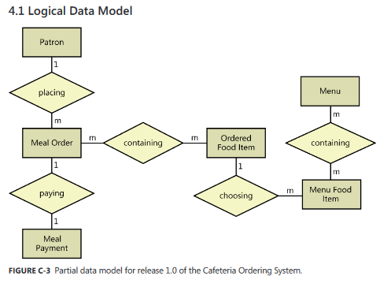

## 4.2 Data dictionary

|  |  |  |  |  |
| --- | --- | --- | --- | --- |
| **Data Element** | **Description** | **Type / Composition** | **Length** | **Values** |
|  |  |  |  |  |
|  |  |  |  |  |
|  |  |  |  |  |
|  |  |  |  |  |
|  |  |  |  |  |
|  |  |  |  |  |
|  |  |  |  |  |

## 4.3 Reports

|  |  |
| --- | --- |
| **Report ID** | **SS-HCG-1** *(SuperficalSol. Hornet Card Gen 1)* |
| Report Title | Faculty Information Card |
| Report Purpose | To provide students with faculty member office hours |
| Priority | High |
| Report Users | Sacramento State University Students |
| Data Sources | * Exported Registrar CVS file * Hours entered by Office Clerk |
| Frequency and Disposition | FICs are generated four at a time upon request of the Office Clerk (see SS-HCG-2). The cards will be affixed near the office of each faculty member present on the card. |
| Latency | No user detectable latency in generation |
| Visual Layout | Cards are generated in landscape to fit on each 5.5x4.25” section of Avery 5689 Cardstock. |
| Report Body | The following information must be included on each card:   * Name of Instructor * Class Schedule   + Course Number   + Class Week Days   + Class Hours   + Class Room * Office Hours * Contact information |
| End-of-Report Indicator | None (?) |
| Interactivity | None |
| Security Access Restrictions | Only an Office Clerk or Admin may generate FICs. Any person with access to the CSU Sacramento campus may view the cards. |

|  |  |
| --- | --- |
| **Report ID** | **SS-HCG-2** |
| Report Title | FIC Sheet |
| Report Purpose | To provide Office Clerks with four cards arranged in Avery 5689 Cardstock format for printing. |
| Priority | High |
| Report Users | ECS Department Office Clerks |
| Data Sources | * FICs (see SS-HCG-1) |
| Frequency and Disposition | FIC Sheets are generated shortly before the beginning of each semester at CSU Sacramento by Office Clerks. The number of sheets to be generated can be calculated by taking the ceiling of the number of faculty members teaching courses in a semester divided by four. |
| Latency | No user detectable latency in generation |
| Visual Layout | Card sheets are printed in Landscape to fit the format of Avery 5689 Cardstock. |
| Report Body | Each FIC Sheet must consist of four FICs (SS-HCG-1). Each FIC must take a quarter of the 8.5x11” page as arranged in Avery 5689 Cardstock. |
| End-of-Report Indicator | None |
| Interactivity | None |
| Security Access Restrictions | Only an Office Clerk or Admin may generate FIC sheets. |

|  |  |
| --- | --- |
| **Report ID** | **SS-HCG-3** |
| Report Title | Current Faculty Member Office Schedule |
| Report Purpose | To provide the clerk with detailed information regarding office hours for the department of the current semester. |
| Priority | Low |
| Report Users | ECS Department Office Clerks |
| Data Sources | * Exported Registrar CVS file * Hours entered by Office Clerk |
| Frequency and Disposition | Report will be generated on demand by Office Clerk. This Report’s data will be dynamic. Report will display in the web browser. It can be printed if the browser permits it. |
| Latency | Complete report will be displayed to the Office clerk at a reasonable time based off web browser and current network traffic. No more than 10 seconds. |
| Visual Layout | Landscape |
| Report Body | Header contains the report title, semester, and date of request. Footer contains the page number. |
| End-of-Report Indicator | None |
| Interactivity | None |
| Security Access Restrictions | Can only retrieve information already available to the office clerk. |

## 4.4 Data acquisition, integrity, retention, and disposal

All faculty member information apart from their office hours shall be initially input into Hornet Cardgen through import of the csv formatted file exported from the Registrar Database. The member’s office hours will be appended to the imported information by the Office Clerk or Office Admin, and must be initially obtained externally from the system by the user.

New semesters may be created through import of the Registrar Database csv file, or by reusing information from one of the prior two semesters. If information from a previous semester is reused, the user must confirm that each individual entry is still accurate.

All data entered into Hornet Cardgen must be retained indefinitely. If any data is to be deleted, it must be done manually and externally.